

**University of Petroleum**

**and Energy Studies**



**Cloud Bus Pass System**

**PROJECT REPORT**

Cloud Based Bus Pass System

# BACHELOR OF TECHNOLOGY

Specialization in Cloud Computing and

Virtualization Technology

SUBMITTED BY

* Gaurav Porwal (R110219054)
* Anirudh Kushwah (R110219015)
* Kushagra Joshi (R110219061)
* Nayan Naugain (R110219090)
* Kumar Baibhav (R11021074)

GUIDED BY

- Yogesh Ghorpade

# Table of Contents

|  |  |  |
| --- | --- | --- |
| **S.No** | **Topic** | **Pg. No** |
| 1. | Aim | 3 |
| 2. | Technologies | 3 |
| 3. | Requirements | 3 |
| 4. | Design and Architecture | 4 |
| 5. | Implementation | 7 |
| 6. | Unit testing | 8 |
| 7. | Snapshots | 10 |
| 8. | Conclusion | 12 |
| 9. | References | 12 |

## Aim

The advent of Cloud Computing has been a miraculous phase in the history of computer science. Cloud computing is the on-demand provisioning of the computer resources as well as the computing services such as servers, databases, networking, and analytics over the Internet with pay-as-you-go pricing that offers faster innovation, flexible resources, and also the economies of scale. In this modern time where technology is advancing at such a faster rate. It has become a problem for the organizations to keep up with the pace thus cloud computing removed pressure from those responsible for manufacturing better machines to keep up with the growing complexities of problems.

Though cloud computing provides a platform for maximum utilization of resources and the services can be accessed from anywhere over the internet the major challenge to such a phenomenal technology is its security. So, the project proposes to use a cloud-based bus pass system for booking tickets which is user friendly and easy to use.

## Technologies

The bus pass system is developed using Hypertext Markup Language (HTML), Cascading Style

Sheets (CSS), JavaScript (JS), Bootstrap and Node.js, Express.js and react. Database: Mongo DB is used to store and maintain passengers’ information. The Non-Relational database was taken because it offers high performance, high scalability, high reliability and Flexibility and for deploying the system AWS is used.

## Requirements

**1. Hardware Components:**

Primary Memory (RAM) - 4GB and higher

Secondary memory (ROM) - 5-GB and higher

Processor - Intel CORE i3 and higher

**2. Software Components:**

OS: Windows 10

Cloud: AWS, AZURE

Front end: Html, CSS, Java Script, Bootstrap

Back end: Cloud shell, Node JS, Express.JS, React.JS

Database: MongoDB

## Design and Architecture

In the traditional system, pass generation and renewal was a manual process. The user had to visit the office and submit their details and wait for approval which is a time-consuming way. A cloud-based bus pass system is a digital approach where we can remove the limitations of the traditional system. With a digital pass the hassle of getting a physical pass is eliminated. This model provides the flexibility of issuing bus pass online. The main objective of this system is to automate pass issuing procedure and enable safe and secure payments as well through the use of UPIs.

This project works on the two different parts

1. Graphical User Interface
2. Web Application

### Sequence Diagram

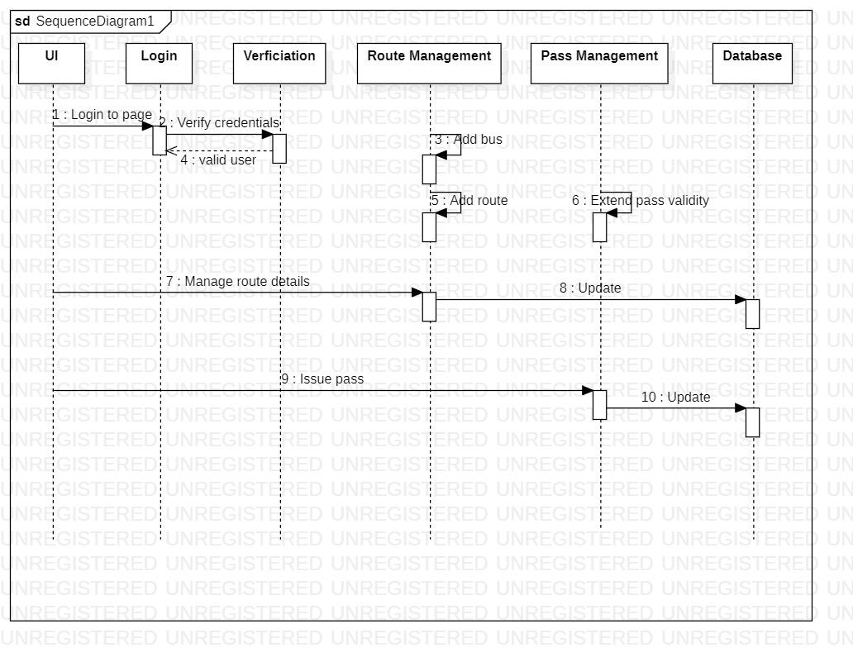

### Activity Diagram

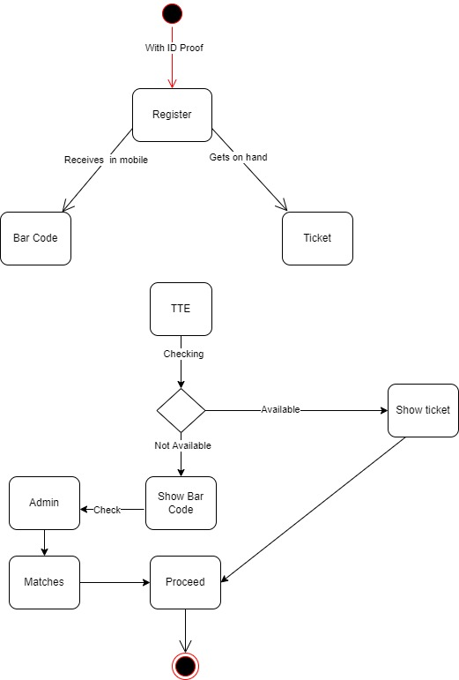

### Process Flow

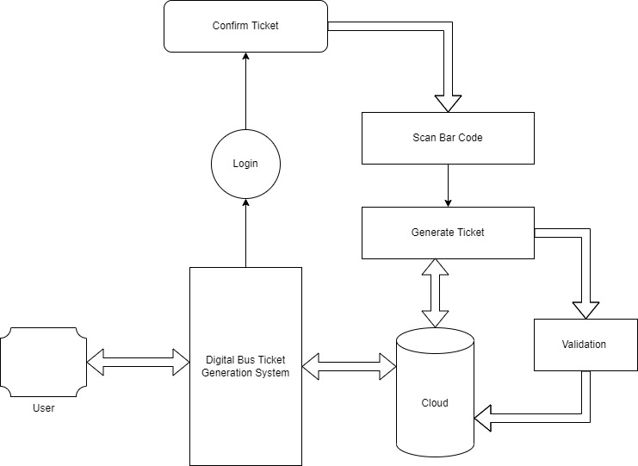

# Implementation

This project is a web-app that is build using the Express, MongoDB, Node.js and for the frontend we used HTML, CSS and some JavaScript. The main advantage of using the MERN is that it makes the development easy. The main advantages of using the above technology and framework is that, it all uses the same programming language i.e., JavaScript. JavaScript being the most popular language if we encounter any problem it can be easily solved.

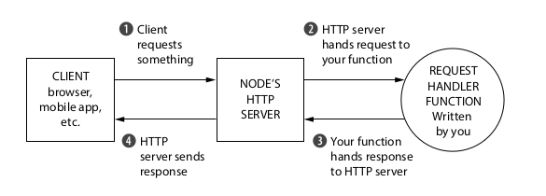

We have created the Web-App using Express. Express is a minimal and flexible node.js web application framework that provides a robust set of features for web and mobile applications. Express is a free open source software under the licence of MIT. It has been called the de facto standard server framework for Node.js.

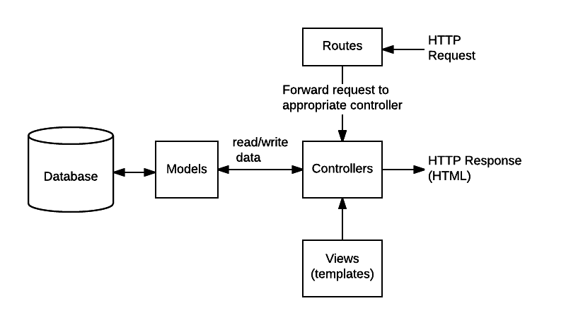

## Unit Testing

Unit tests test the functionality of an individual unit of code isolated from its dependencies. They are the first line of defence against errors and inconsistencies in your codebase. They test from the inside out, from the programmer's point of view.

In Express we can use mocha and chai extension. We can use mocha and chai by installing it by using “npm install – D mocha chai”

The process of performing the unit tests in mocha and chai:-

1. Storing the unit tests
2. Creation of the basic unit test file
3. Running of unit tests
4. Addition of more helper function for facilitating more unit test development.

# Snapshots

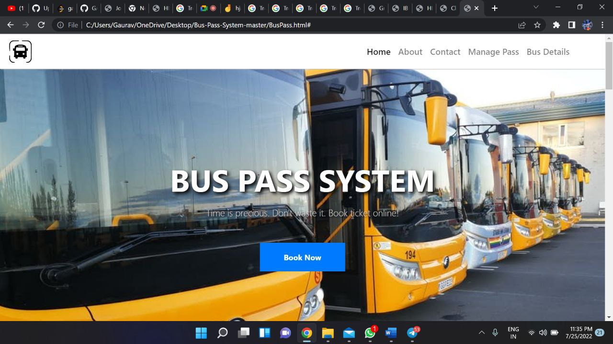

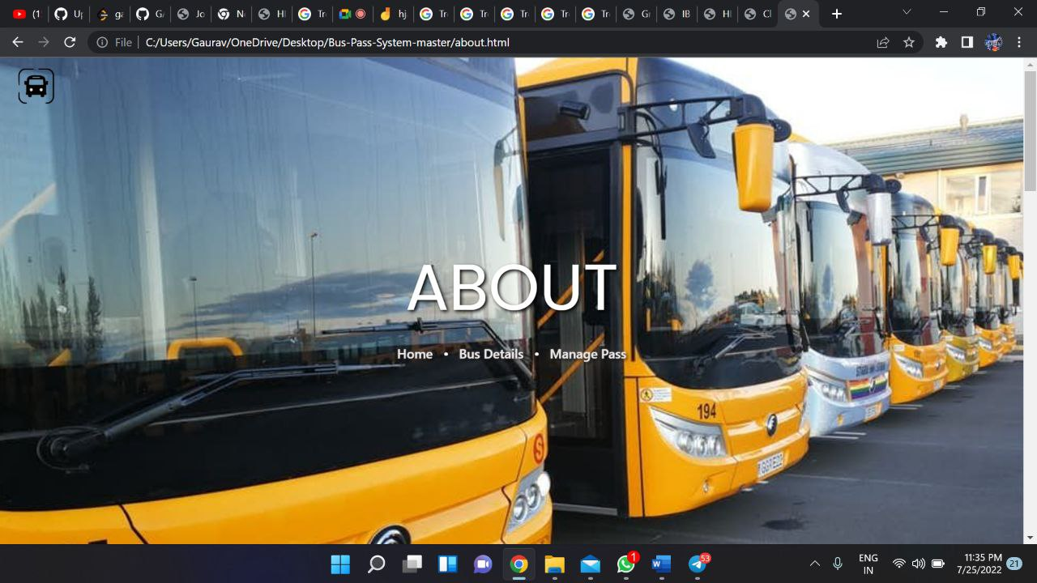

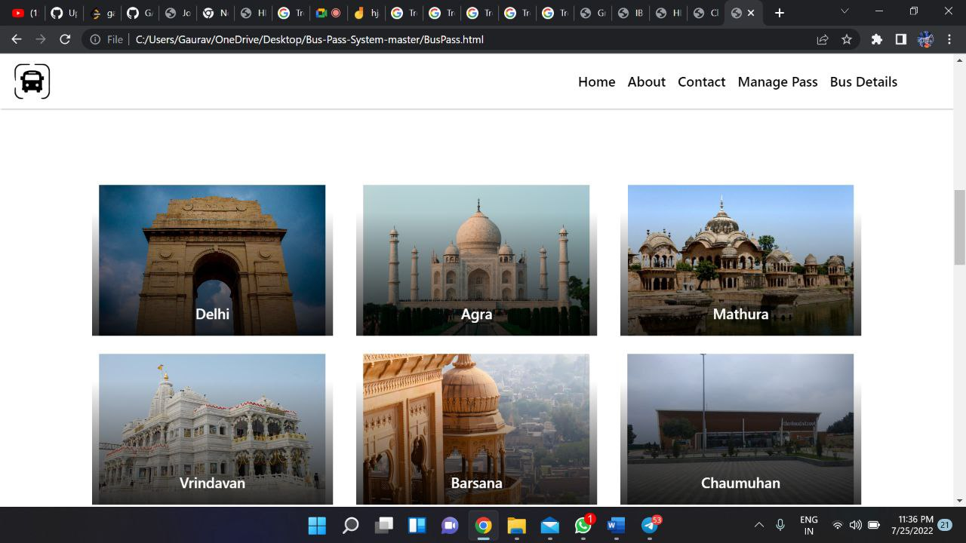

## Conclusion

The proposed project aims to address the problem of manually issuing bus pass and booking tickets. This method is a basic implementation of the proposed methodology that can be improvised and customised according to the needs. It proposes to use a cloud-based platform to issue pass and book tickets. The users can access the system in real time and book tickets based on their destination, route and departure time.

## References

[1] https://www.researchgate.net/publication/329073305_Cloud-Based_E

Learning_Using_Cloud_Computing_Platform_for_an_Effective_E-Learning

[2] S. Kim, “Security Augmenting Scheme for Bus Information System based on Smart Phone”, International Journal of Security and Its Applications, vol. 7, no. 3,(2013), pp. 337-345.

(Accessed on 22 June 2022)

[3] J. Lee, K. Hong, H. Lee, J. Lim and S. Kim, “Bus information system based on smart-phone Apps”, in Proc.of KSCI Winter Conference (2012), pp. 219-222.

(Accessed on 25 June 2022)

[4] S. Chandurkar, S. Mugade, S. Sinha, M. Misal and P. Borekar, “Implementation of Real Time Bus Monitoring and Passenger Information System”, International Journal of Scientific and Research Publications, vol. 3, no. 5,(2013), pp. 1-5.

(Accessed on 25 June 2022)